Introduction

Project planning is the most vital phase in the project life cycle. This is the formal transfer of customer requirements into “a project”. A project manager is identified and inducted to take complete charge of the project.

Scope
- This procedure is applicable to projects of all types

Process Practitioner
PM, PL

Objective
- To make comprehensive plan of the project which will be the basis for project monitoring
- To draw a plan that will ease project management tasks

Entry

Criteria
One or more of

Acceptance of proposal and project awarded
Any form of intimation to start a project
Approval to start an internal initiative
Any work that is qualified as a “project” and requires to be planned and controlled

Input
One or more of

Contract
Letter of intent
Purchase order
Email notification to start a project
Proposal
Estimates

Flow Chart

Reoccurring at each PDLC
START
END
Letter of intent or PO, or contract, or intimation
Assimilate Project Data
Proposal, Estimates Baselines,

Select Project Type
Register and Initiate Project
Kick-off Project

PreparePMP

Prepare MPP

Start Audit

Release 1st version PMP

PDLCPhase Planning

PMP
Resource Register
RML

MPP

Tasks

Sub-Process | Responsibility

Assimilate Project Data
- Assign project to a PM  - Allocate a PL to the project  - Identify SM for the project  - Refer guideline – “Who is SM for the project” | DH
- Get all project documents and details (Documents like: RFP, proposal, requirements document, estimation, customer background / profile, explicit requirements/ expectations, contract etc)  - Understand the project requirements | PM
- Understand the project requirements | PL

Select Project Type
- State project objectives, critical success factors  - Explain customer SLAs, if and as applicable  - Help project to identify assumptions, risks and risk mitigation plan  - Help in identifying special resources  - Decide SMR frequency and SMR meetings for the project | SM
- Identify project type and select project type from QMS overview | PM
- Help in identifying project type and any required tailoring | SQA

Register and Initiate Project
- Register project in PRS and obtain project ID  - Identify and obtain special resources required from IT Infrastructure  - Document resource requirement in resource register  - Identify any other special services / resources required from HR, TR, Admin  - Initiate meeting with Support groups, as required and prepare MOM  - Set project specific service levels required from Support groups | PM
- Understand the services required by the project  - Commit the agreed service levels | Support group representative

Kickoff Project
- If existing type is not suitable, define new type with the help of SQA  - Refer tailoring guidelines; determine tailoring required in the project and document the same in tailoring section of PMP  - Discuss with SQA and seek approval of tailoring  - Decide start audit date with SQA  - Identify training needs and training waiver for project team. Refer “Guideline for identifying training needs”  - Create resource register  - Conduct meeting with the team, SQA and other concerned to explain project  - Define team structure with specific roles of QL, DPG and CL amongst the project team. Refer guideline – “Project roles”  - Discuss on decision-making or empowerment (decision making by a group) responsibilities and document the same in PMP. Refer guideline - Decision making/empowerment (this point is applicable to Bangalore, Mysore and Chennai centers)  - Discuss the objectives with the team members and set the same in pragati (this point is applicable to Bangalore, Mysore and Chennai centers)  - Assign additional roles like ML, DBA, shadow PL, technical analyst, architect, testing specialist etc as per project requirement etc | PM

Prepare PMP
- Prepare metrics plan, defect prevention plan. Refer Project Defect Prevention and Project Metrics procedure  - Prepare risk management plan and create RML. Refer Risk Management procedure  - Document Customer SLAs, if any  - Describe how PDLC phases will be planned and executed in project  - Check resource register is updated  - Give inputs on project process, tailoring required  - Refer guideline – “PMP preparation tips and About PMP” | PM
- Prepare Configuration Management Plan (CMP). Refer SCM procedure | CL, PL
- Prepare audit plan of PMP | QL, SQA
- Review PMP for metrics plan, team structure, risk management, project objectives, tailoring, Customer SLA  - Refer guideline Review of PMP | SM

Prepare MPP
- Use project estimate for planning MPP  - Prepare a broad level plan of project based on budgetary estimate  - Prepare all major milestones of the project at the beginning  - Detail out the “Requirements analysis” phase of PDLC  - Break it down to detailed tasks / activities  - Create MPP  - Share the MPP with the team  - Refine the plan based on Initial estimate after completion of "Requirement analysis phase"  - Baseline MPP after review | PL
- Ensure that the estimated efforts and schedule is reflected in the MPP  - Verify the MPP | PM
- Understand the allocated tasks and their deadline  - Resolve any issues in meeting the deadline  - Update the status of the activity after completion and book time | Team

Start Audit
- Plan, prepare and conduct start audit | SQA
- Invite PL, QL, for audit  - Invite additional members (optional)  - Close audit findings | PM

Release 1st Version PMP
- Get relevant sections of PMP reviewed by concerned members  - Release 1st version within 1 week. Large projects may take up to 2 weeks time  - Share PMP to all concerned members (development team, onsite coordinator, SQA, marketing team etc) | PM
- Conduct work product audit of PMP  - Approve tailoring by email | SQA
- Review and approve PMP | SM

Phase Planning
Note: This phase is applicable in following scenarios
- At the start of each PDLC phase
- In case there is need to re-plan.
- Detail the ETVX table in the “Project Process” section in PMP for the “current” PDLC phase  - Update the “Review Plan” section in PMP  - Revisit all other sections of PMP and update as necessary | PL
- Verify PMP, revisit RML,  - Approve PMP for minor changes | PM
- Approve PMP for major changes | SM

Guidelines

About PMP
- What is PMP - It is vital internal document guiding the project.
  - SM and PM will use this document to get a view of how the project will be managed, what are the commitments, which are the resources etc.
  - PL will use this document to take a comprehensive view of the project while planning. This plan also acts as a reference to the project while actually managing the project.
  - This plan provides the team, a comprehensive view of the project, its goals, their roles and other plans.
- None of the sections of PMP should be removed. If the section is not applicable, mention by writing “Not applicable”.
- What should PMP contain
  - PMP is the controlling document for managing the project. It defines the technical and managerial processes necessary to satisfy the project requirements.
  - The strategy for updating the PMP should be defined here. Mention the criteria when PMP will be updated.
  - E.g. It is updated prior to each major review with schedule changes, process changes as a result of defect prevention activities, changes to requirements, resource requirement changes, additions and deletions, introduction of new tool, new process etc
- PMP will be updated at the starting of each phase or when ever re-planning is done

Who is a SM (Senior Manager) for the project
- Delivery Head (DH) is the default SM of a project
- Depending on the project size and criticality, DH can appoint a person as SM of a project
- A project can have more than one person as SM
- SM will be responsible for the approval of the PMP and the project management methodology
- SM will conduct SMRs and provide proactive measures to the projects

Project roles
- SM, PM, PL, QL, CL and DPG are mandatory project roles. However one person can play more than one role depending on the project size and criticality
- If one person has to play multiple project roles, combine the role of PM and PL instead of combining the role of PL and QL
- In case of a small project, a QL can be a part time in the project, provided he is NOT a team or PL of the same project. This QL can be a team member, QL or PL of other project
- QL can take up role of CL

Decision making and empowerment:
(This section is applicable to Bangalore, Mysore and Chennai centers)
- Delegation of Decision making authority within a project can be done by the PM.
- If the decision making responsibilities are to be vested with a group rather than individual, the PM could do so and document the same in PMP.
- For either of these options, the PM can refer to the Decision Making Matrix(DMM) at SPANDAN site which lists out the decision making responsibilities of various roles.

Review of PMP

- Review comments of PMP can be maintained in the hard copy or in softcopy using track-on option.
- The review comments will not be counted as defects in the MAP.
- Evidence of review done has to be maintained in emails or hardcopy / softcopy versions of the PMP can be stored

Planning tips
- “Plans don’t fail. We fail to plan”
- Create and use common Email id for project. This would help when project team is large, team members are more than 10 or if the team is situated in more than one locations
- Refer Gyankosh for any components - planned to be used in project. The usage of components will impact the project efforts / or schedule. Take it into consideration
- Define project milestones as activities with “zero” duration. These will help in arriving at the Critical Path Method (CPM)
- CPM in MPP can be used to document the milestones in MAP schedule sheet
- Re-planning / MPP guideline
  - The MPP must be broken down to lowest unit of work that is traceable. The efforts of the lowest unit is desirable to be not more than 40 hours (5 work days)
  - Detail the WBS for the 1st major milestones if not for all the project milestones
  - If MPP cannot have the lowest WBS, additional work allocation sheet should be used. The project can have multiple MPP files and master MPP file
  - Non usage of MPP will require SQA approval

PMP preparation tips
- In case this document is shared with the Customer or is a project deliverable, suitable changes can be made to another copy of the PMP. Irrelevant / sensitive information will be removed. The SM will review these changes before delivery.
- PMP Revision Process
Whenever the PMP is updated following steps are followed:
  - PL updates PMP and PM reviews PMP
  - If the changes are minor, PM will authorize PMP.
  - If the changes are major, SM will authorize PMP
- Project Objectives and Critical Success Factors
  - List all the project objectives and critical success factors of the project. These objectives will include project specific objectives.
  - Common objectives like meeting metrics goals, meeting timeline etc will not be identified as objectives.
  - This section will be required for internal and training projects as well. (Infact they are more relevant to such projects).
  - Every project should set their own specific objectives depending on the project needs
  - Following is a sample list. Projects will determine their own list in the PMP
    - To capture learning on new technology and create KM capsules / components
    - To gain Customer confidence in the first prototype
    - To win confidence of Customer in 1st two months and meet the SLAs
    - To establish smooth communication channels for spreading awareness among all parties involved in executing the project. At the same time eliminating any redundant or unwarranted flow of information
    - To ensure sustained level of high quality input
    - To ensure continuous productivity environment
    - To outline risks in executing the project and to prepare a risk mitigation strategy and plan to address those
    - To handle changes to the scope using the change requests procedures
  - Following will NOT be set as objective as it is expected to be prevailing
    - To ensure adherence to the schedule
    - To ensure to adhere to metrics goals
- Project team structure
  - Detail the project team structure at offshore.
  - Depict the communication channel and escalation path with in team and to Customer. The team will follow this structure for issue resolution and escalations
  - Refer to sample Project team structures

Guidelines for identification of training needs
Identify the training needs for
Process areas in QMS: Refer the table below for role-wise training chart. Training needs also can be identified for basic process areas like estimation, Testing depending upon criticality.
Technology: Based on the gap between requirements of skills and available skills.
Domain knowledge: Depending on the domain and need of depth of knowledge. This could be critical in case of functional consulting or people going for requirements gathering.
Tools: Depending on the tools used in project
Soft skills: Based on the role (leadership), size of project (Team building), Type of customer (Cultural sensitivity, language), critical areas (Communication, presentation) of the project.

Training Waiver
If the SBU Head / PM / PL finds that some of the team members already have the necessary skills and do not need the training then they can be given exemption from training on those skills. If any member from the projects group had worked on similar technology a year back or has already undergone training on the required technology then the member can be given waiver for those skills. All training waivers should be mentioned in the training plan of resource register.

Role training chart
 | Roles/ trainings | TM | PL | QL | PM | SM | DPG, D PC | QA (SQA, SEPG, Metrics) | TCMG | Support groups
 | ISO 9000:2000 Awareness (repeat every 18 months) | ✓ | ✓ | ✓ | ✓ | ✓ | ✓ | ✓ | ✓ | ✓
 | SEI-CMM Introduction (repeat every 18 months) | ✓ | ✓ | ✓ | ✓ | ✓ | ✓ | ✓ | ✓ | ✓
 | Quality Management System (QMS) Introduction | ✓ | ✓ | ✓ | ✓ | ✓ | ✓ | ✓ | ✓ | ✓
 | QMS Introduction to Support Groups |  |  |  |  |  |  |  |  | ✓
 | IT Security-BS7799 Awareness Training | ✓ | ✓ | ✓ | ✓ | ✓ | ✓ | ✓ | ✓ | ✓
 | Balanced Score Card |  |  |  |  | +
B. Role Based Trainings (RBT)
 | Team Member | ✓ | + | +
 | Project Leader |  | ✓ |  | +
 | Quality Leader | + | + | ✓ |  |  | + | +
 | Project Manager |  |  |  | ✓
 | Senior Manager |  |  |  |  | ✓
 | Quality Assurance |  |  | + |  |  |  | ✓ | +

C. Process Functions
 | Defect Prevention (DP) | ✓ | ✓ | ✓ | ✓ | + | ✓ | ✓
 | Peer Review (PR) | ✓ | + | + |  |  | + | +
 | Software Configuration Management (SCM) | ✓ | ✓ | ✓ | + |  |  | +
 | Quantitative Process Management (QPM) - Basics | ✓ |  | ✓ |  |  | ✓ | ✓
 | Quantitative Process Management (QPM) – Advanced | + | ✓ | ✓ | ✓ | + | ✓ | ✓
B. Process Tools
 | DTS | ✓ | ✓ | +
 | MPC | + | ✓ |  | +
 | Project Suite |  | + | ✓
 | Gyankosh (Self study using user manual) |  | ✓ |  | ✓
(✓ Mandatory, + Supplementary)

Sample team structures

Sample A

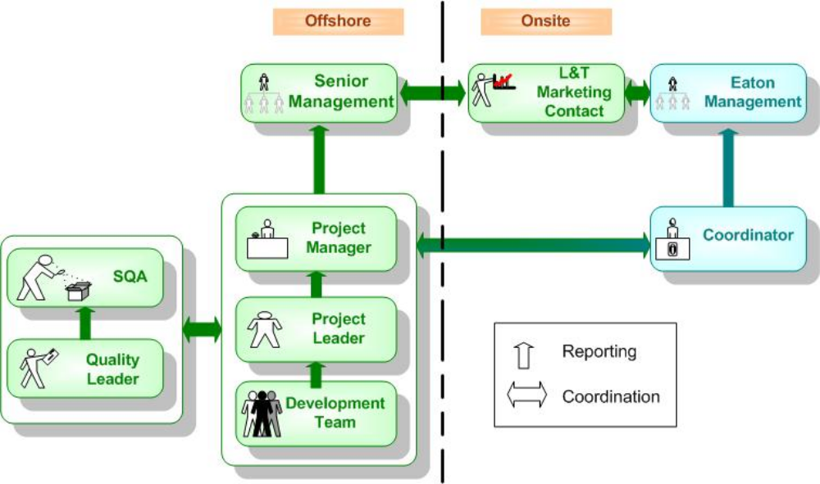

Sample B



Quality Leader
Q.A.
Team
Q.A. Team
SQA
Account
Manager

Project Manager
Development Team
Project Leader
LTIL Marketing
Contact
Customer Senior Management
Onsite
Offshore

Customer Project Manager
LTIL Onsite Development Team
LTIL Onsite Co-or.
Account
Manager
LTIL Senior Management

Sample C (ODC team structure)
Delivery Head
SBU Head
L&T Onsite Project Team(s)
Functional Experts
Developers
Developers
Developers
ODCR
ODCR
Project Manager(s)
L&T OFF-Site Center
Functional Experts
Developers
Developers
Developers
ODCR
ODCR
Project Manager(s)
Project Manager(s)
Project Manager(s)
Maintenance Team(s)
Project
Lead(s)
QL
Team
Members
Team
Members
Development Team(s)
Project
Lead(s)
QL
Team
Members
Team
Members
Functional
Experts
ODC Head
Account Manager
& Sub-Account Managers
ADSM Relationship Manager
Relationship Office
ADSM Technical Director
ABN AMRO

Checklists / Standards
NA

Associated Templates, tools

Templates |  | Tools
PMP |  | Common Email id for project
RML |  | VSS script
Estimation Sheet |  | MPC, MPP
Resource Register

MAP

Control Mechanism

Effort variance and schedule variance.
These metrics will partly indicate the planning process. Refer the Metrics guidelines for details.

Set appropriate metrics goals.
SMR will review the metrics goals set.

Verification

Item | Activity | Who
Project Id | Verify project data | SQA
PMP | Review PMP  Approve PMP  Review CMP  Review quality plan, tailoring, metrics plan  Review defect prevention plan | PM  SM  CL  SQA  DPG
MPP | Review MPP  Approve MPP | PM  SM
MAP | Review  Verify | PM  SM
Resource register | Verify resource register | SM
Project specific SLA | Approve SLA | IGCC, SM

Exit

Criteria
Start audit is conducted and metrics goals are set
PMP and MPP updated for every phase
OR
1st version of PMP is released

Output
Start audit log
1st version of PMP
Resource Register
MPP

Tailoring

In case of small projects, and where there is shortage of resources, the PM can play role of PL, rather than PL playing role of QL.

References

It will help in planning and managing smaller tasks – every day. Refer To Do List.exe
Refer to this guide on Project Planning. Wampof-PP.pdf

